The 8th of November
- Good afternoon, my dear students!
- Here are the tasks for today:

- Watch and listen the video:
Present Simple. Настоящее простое время. Английская грамматика. Видеоуроки Myefe. - поиск Яндекса по видео (yandex.ru)
- Write the sentences in the Present Simple:
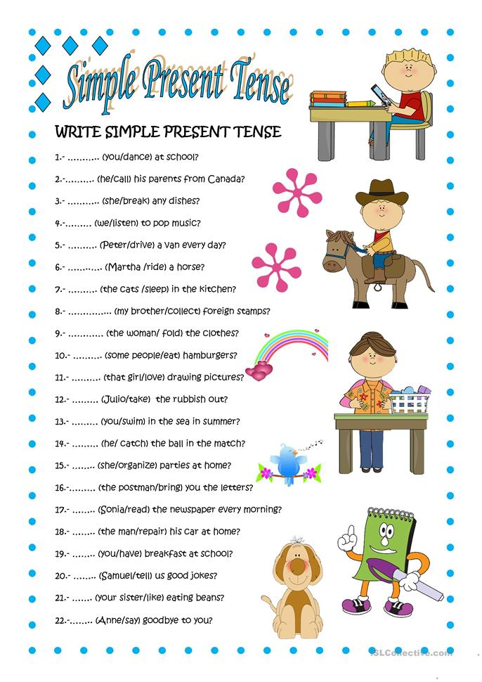
- I’m waiting for your answers to the e-mail ayatsydenova@mail.ru until November, 9

