The 11th of November
- Good afternoon, my dear students! Today we are completing the grammar about Present Simple
- Here are the tasks for today:
- Write the sentences in the Present Simple:
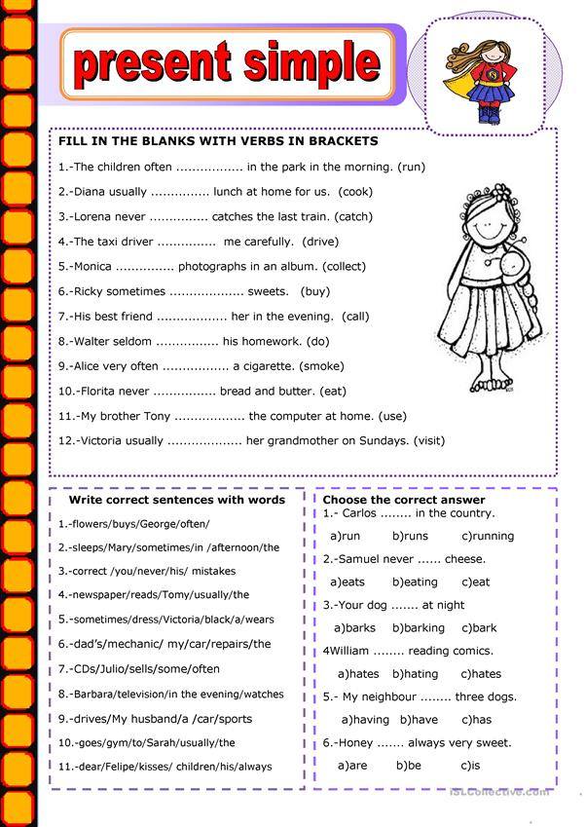

- I’m waiting for your answers to the e-mail ayatsydenova@mail.ru until 18:00

